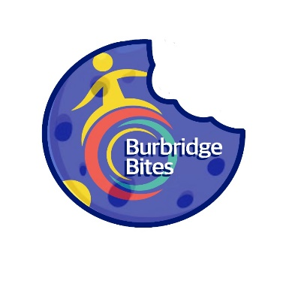 **Burbridge Bites Order Form Term 4 2025**

**Open Monday and Wednesday**

Please send this order form along with all money in a sealed bag/envelope to your child’s classroom teacher on the day please.

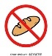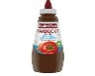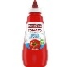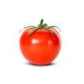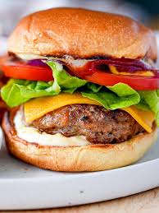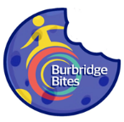

**Ingredient List (please tick**):

Chicken Patty

**OR**

Beef Patty

-----------------------------------------------------

Lettuce

Tomato

Cheese

Tomato Sauce

BBQ Sauce

**NO** Bun

**Burbridge Bites Order Form: MONDAY**

**Burger: $5 per serve**

Name: _________________________ Class: __________

Quantity: __________ $ Enclosed: __________

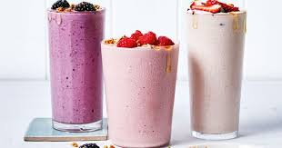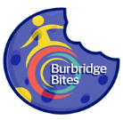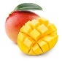

**Burbridge Bites Order Form: WEDNESDAY**

**Smoothie: $3 per smoothie**

Name: _________________________ Class: _____________________

Banana

Quantity: _________ $ Enclosed: _________ Flavour (please tick one): Strawberry

Mango